Test Result and Defect Summary
Test Result

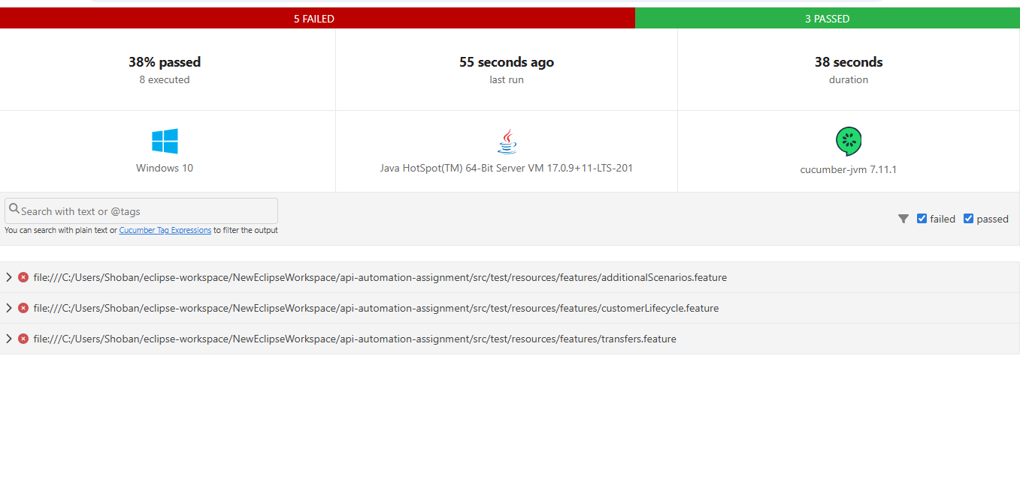

Defect Summary
Defect Id: APIAS1
Title: When I’m trying the get the account details using account details API getting 302 status code
Env: QA
Preconditions: An customer with Account should exists
Steps to Reproduce:
  - Create a new customer and add an account to the customer
  - Trigger the get call to get the account details
    - GET /accounts/{accountNumber}
  - Expected Result: It should show account details with status code 200
  - Actual Result: But it showing account details with status code as 302
Screenshots:
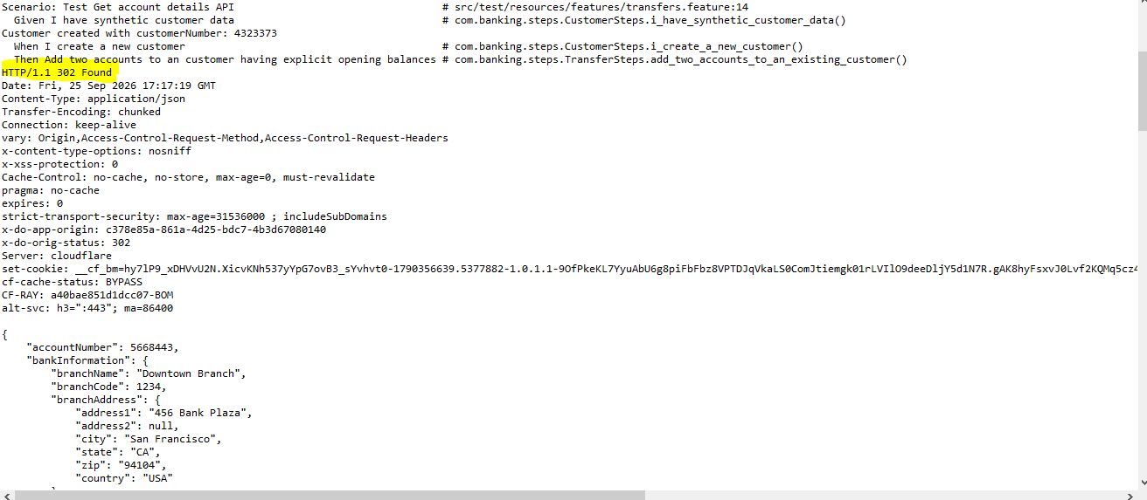
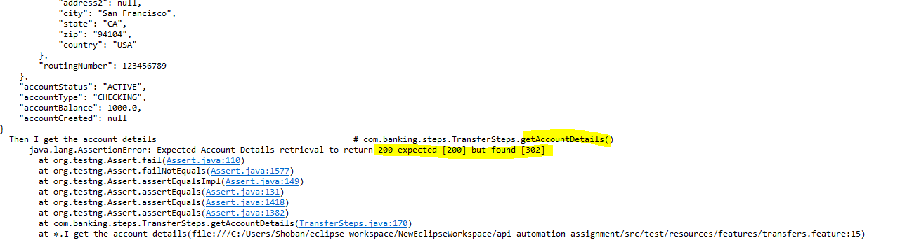

Defect Id: APIAS2
Title: Negative amount transfer should throw an error but the transaction happening successfully
Env: QA
Preconditions: An customer should exists with two account and sufficient balance on it
Steps to Reproduce:
  - Create a new customer and add an 2 accounts to the customer with balance in it
  - Trigger the put call to intiate the transfer with negative input in the body
    - PUT /accounts/transfer/{customerNumber}
- Expected Result: Negative amount transfer should throw an error with error 400 series
- Actual Result: Transfer is happening successfully with 200 status code
Screenshots:
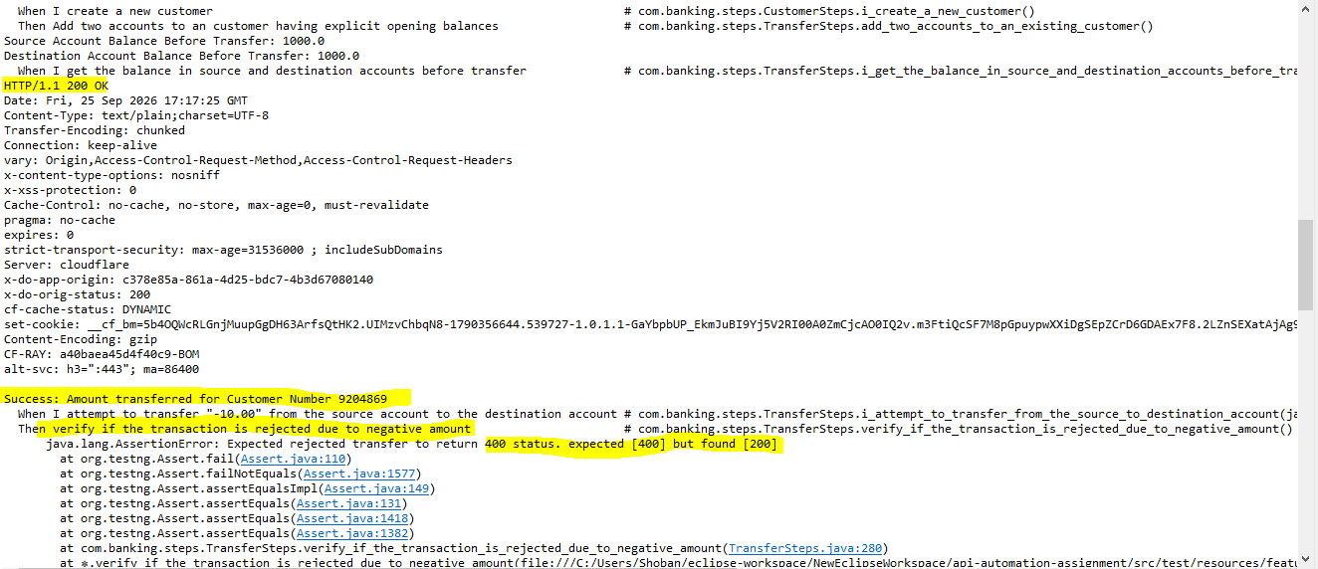

Defect Id: APIAS3
Title: Retrieving the deleted customer without account returns 200 response with incorrect response
Env: QA
Preconditions: A customer should be created
Steps to Reproduce:
- Create a new Customer
- Retrieve the details
- Update the customer
- Retrieve the customer details
- Delete the customer
- Retrieve the details using the
  - Get /customers/{customerNumber}
- Expected Result: Retrieval of the deleted customer details should throw an 404 error
- Actual Result: But it is showing incorrect response with 200 status code

Screenshots:
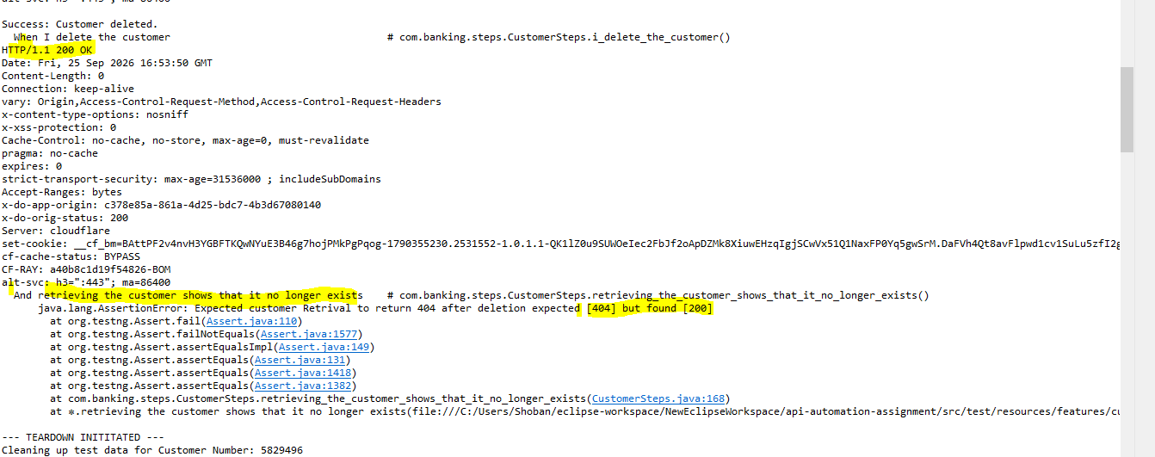

Defect Id: APIAS4
Title: Retrieving the deleted customer with account returns 200 response with incorrect response

Env: QA
Preconditions:
Expected Result:
Actual Result:
Steps to Reproduce:
- Create a new Customer
- Add an account to the customer
- Retrieve the details
- Delete the customer
- Retrieve the details using the
  - Get /customers/{customerNumber}
- Expected Result: Retrieval of the deleted customer details should throw an 404 error
- Actual Result: But it is showing incorrect response with 200 status code

Screenshots:
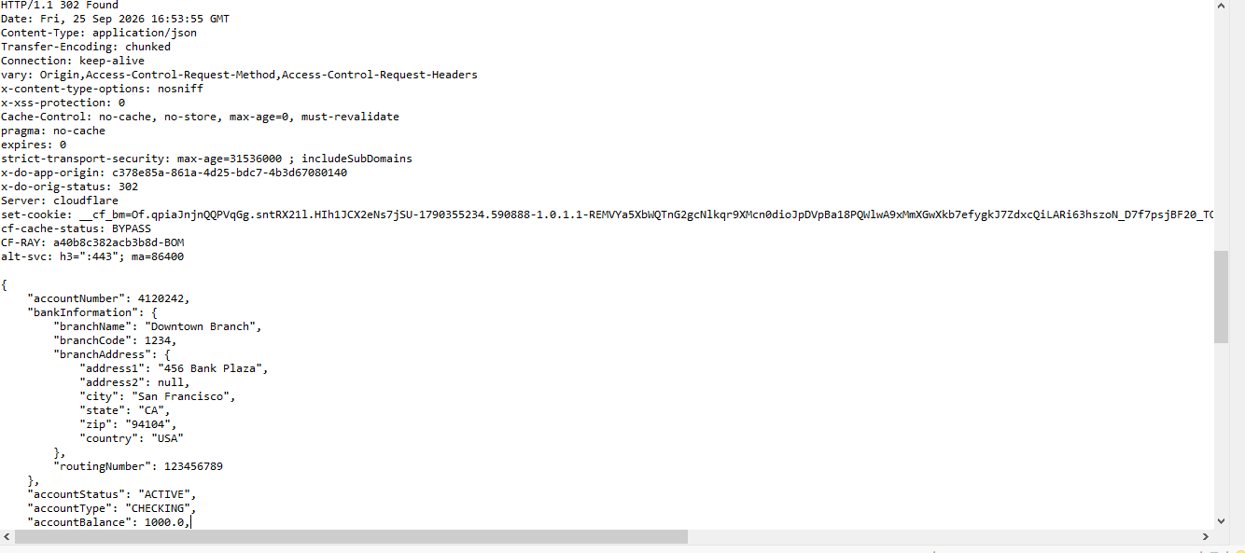
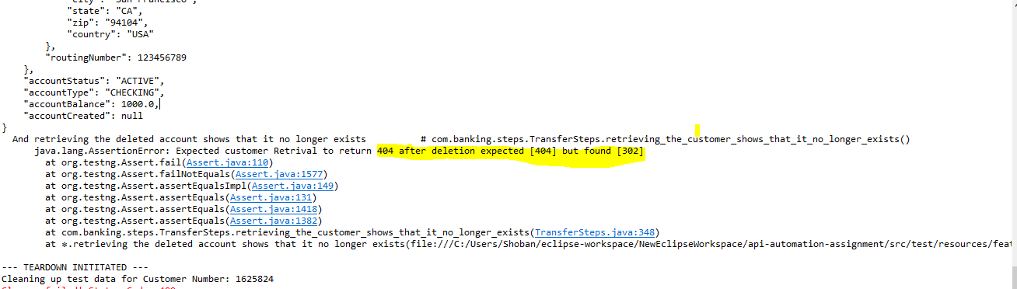

Defect Id: APIAS5
Title: Retrieval of the Non Existing customer reference showing 200 status
Env: Base
Preconditions: Customer should not exist
Steps to Reproduce:
- Customer should not exist
- Retrieve the details using the
  - Get /customers/{customerNumber}
- Expected Result: It should display an error with 404 not found error
- Actual Result: But we are getting 200 status code response
Screenshots:
